**03/13 Morning Reading 晨間閱讀文章 文章整理：雙語辦公室**

閱讀時間：03/13早修

Take out your dictionary first. 請學生使用英漢字典查單字。

**Follow the steps when you read.**

**Step1🡪** Read once. When you read, highlight the words you don’t know. 讀一遍，將你不知道的字用螢光筆畫起來。

**Step2🡪** Find at least five words you don’t know to look them up in the dictionary. Then write down the Chinese meaning. 找至少五個你不知道的單字，並且查字典，寫出中文意思。

**Step3🡪** Read again. 再讀一次。

Let’s start!

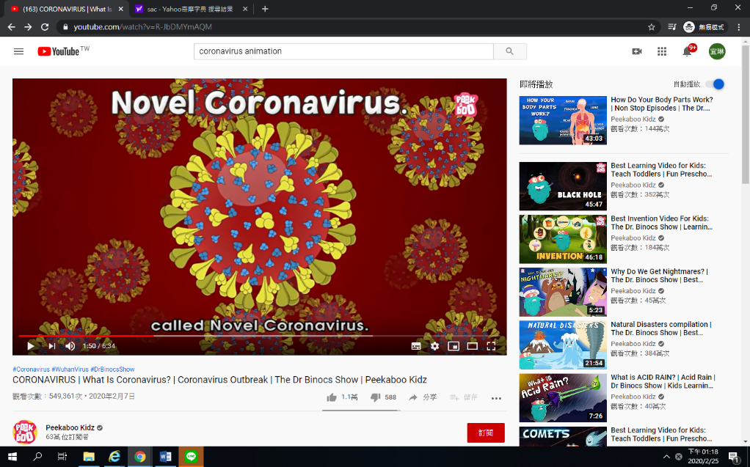

Hey Kitty, get ready quickly. It’s an emergency. We need to visit China!

China? Yes, little Kitty, people there are suffering from a new deadly outbreak caused by Coronavirus, and I have been called there to research it.

Hey, Kitty, 動作快點，事態緊急。我們要去中國一趟!

中國？是的，Kitty，那裡的人正面臨由冠狀病毒引起的疫情，我被叫去那邊做研究。

Hey, friends, I am sure since the past few weeks. You have heard a lot about this new disease called Coronavirus. So in today’s episode, let us try to explore what exactly this virus is, what are the causes, symptoms, and measures we need to take to stay safe from this illness called Coronavirus! ZOOM IN!

嘿，朋友們，我相信這是過去幾週以來的事情。你已經聽說過很多有關這種冠狀病毒的新疾病。因此，在今天的這一集中，讓我們探究這種病毒的確切含義，為了預防這種稱為冠狀病毒的疾病而需要採取的預防措施，成因，症狀。

Hey friends, by now, most of us are aware of the outbreak of the disease started in Wuhan, China caused by a new species of virus called Novel Coronavirus.

They belong to a member of the corona virus family. That was first identified in the 1960s. They are responsible for causing a range of diseases in humans, including the common cold and more severe and life threatening forms like SARS and MERS. But the crucial question is, how did the recent outbreak occur?

嗨，朋友們，到目前為止，我們大多數人都知道這種疾病是在中國武漢開始的，這種疾病是由一種新型的新型冠狀病毒引起的。

它們屬於冠狀病毒家族的成員。這是在1960年代首次發現的。它們引起人類多種疾病，包括普通感冒，更嚴重和威脅生命的形式，例如SARS和MERS。但是關鍵的問題是，最近的爆發是如何發生的？

Well, like other coronaviruses, it has come from animals too and is a form of zoonotic disease. Many of those infected patients either worked or frequently shopped in the Huanan seafood wholesale market in the center of the Chinese city, which sells meat and live animals. It is believed that the virus might have been transmitted through direct contact between humans and animals either by touching those animals or consuming them, and it can also spread via the air like other cold causing viruses. However, unfortunately, the actual source of this disease isn’t confirmed yet, and scientists are still trying to figure it out.

就像其他冠狀病毒一樣，它也來自動物，是人畜共患病的一種形式。這些受感染的患者中有許多人不是在中國華南海鮮批發市場工作，就是在這邊購物，而這個市場出售肉類和活體動物。據說，該病毒可能是通過人與動物之間的直接接觸而傳播的，可以通過接觸這些動物或食用它們，也可以像其他病毒一樣通過空氣傳播。但是，不幸的是，這種疾病的真正來源尚未得到證實，科學家仍在設法找出答案。

But what we know so far is its symptoms and how it affects humans. Yes, a person infected from this disease may suffer from dry cough, mild fever, and breathing issues, which may go unnoticed at first. But, as the virus spreads its legs inside the person’s body, the patient might develop a severe case of viral pneumonia, an infection that inflames the air sacs in the lungs and can cause them to fill with fluid or pus and needs immediate medical attention. Also, it is believed that these viruses are more likely to infect older people and those with a weak immune system that find it hard to fight these notorious viruses. But, is there any way to treat this disease? Well, unfortunately, all this is a very new illness, no treatment for it is available so far, and because it is a virus, antibiotics won’t work against it.

但是到目前為止，我們所知道的是它的症狀以及它如何影響人類。沒錯，感染這種疾病的人可能會出現乾咳，輕度發燒和呼吸問題，這些問題一開始可能不被注意到。但是，隨著病毒在人體內傳播，患者可能會發展為嚴重的病毒性肺炎，這種感染會惡化肺部的氣囊，並導致其充滿積液或膿液，需要立即就醫。另外，這些病毒更可能感染老年人和免疫系統較弱的人，這些人發現很難與這難纏的病毒對抗。但是，有什麼方法可以治療這種疾病？好吧，不幸的是，所有這一切都是一種非常新的疾病，到目前為止，尚無針對性的治療方法，而且由於它是一種病毒，因此抗生素無法抵抗這種疾病。

Now ,here comes the most crucial question, What can we do to stop this outbreak?

Well, it is always advisable to practice good hygiene and caution by avoiding close contact with individuals suffering from acute respiratory infections or wild animals or livestock, dead or alive. Also, it would be best if you wash your hands with warm and soapy water regularly, especially after being in direct contact with an infected person.

And if you find any of the mentioned symptoms, do visit your doctor asap.

現在，最關鍵的問題到了，我們該如何制止這種爆發？

建議始終保持良好的衛生習慣和謹慎態度來避免與患有急性呼吸道感染的人或是死掉或活著的野生動物或牲畜密切接觸。另外，最好定期用溫肥皂水洗手，尤其是在與感染者直接接觸後。

並且，如果您發現任何上述症狀，請盡快就醫。

Did you know the virus is named after its shape, which takes the form of a crown with protrusions around it and hence is known as Coronavirus. Also, the full name of the current form of Coronavirus under outbreak is the 2019 Novel coronavirus or 2019 nCoV.

您是否知道該病毒是根據其形狀命名的，其形狀為冠狀，周圍帶有突起，因此被稱為冠狀病毒。此外，正在爆發的冠狀病毒當前形式的全名是2019 Novel冠狀病毒或2019 nCoV。

資料來源；Peekaboo Kidz