**06/12 Morning Reading 晨間閱讀文章 文章整理：雙語辦公室**

閱讀時間：06/12 早修

**Take out your dictionary first. 請拿出你的英漢字典**

**Follow the steps when you read.**

**Step1→** Read once. When you read, highlight the words you don’t know.

讀一遍，將你不知道的字用螢光筆畫起來。

**Step2→** Find at least five words you don’t know and look them up in the dictionary. Then, write down the Chinese meaning.

找出至少五個不懂的單字，並查閱字典，寫出中文意思。

**Step3→** Read again.

再讀一次。

**Be Careful When Crossing the Street! Drivers May Not See You**

Statistics show 60 percent of all traffic accidents occur at intersections. The big turning radius and major blind spots of large vehicles are problems that contribute to claiming many precious lives every year.

根據統計顯示有60%交通事故發生於十字路口。 轉角大車內輪差和主要盲區是導致每年奪走許多寶貴生命的原因。

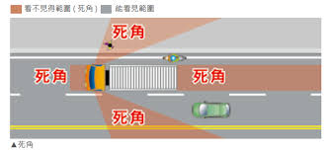

The Ministry of Transportation and Communications is now urging drivers not only not to run red lights but also to “slow down, look and stop” and let pedestrians cross at intersections. The agency also hopes to foster greater risk awareness on city streets.

交通部呼籲駕駛員不僅不要闖紅燈，而且要“減速、看和停”，並先讓行人在交叉路口過馬路。交通部也希望提高人們在路上的危險意識。

Motorbike riders, bicycle riders, and pedestrians, for example, should avoid being next to, in front of or behind large vehicles. Pedestrians should also avoid crossing streets when there is not enough time left on the green pedestrian crossing signal and be aware that drivers’ sight may be blocked.

例如，摩托車騎士，自行車騎士和行人應避免在大型車輛旁邊，前面或後面。當小綠人號誌快走完時，行人應不再過馬路，並注意駕駛員的視線可能會被擋住。

**Five Tips for Crossing Roads Safely 安全過路口五秘訣**

While waiting for a green light to cross the street, stand three steps back from the curb to avoid potential danger caused by the big turning radius of large vehicles.

在等待綠燈穿過馬路時，要離路口邊緣三步停等，避免轉角大型車輛的內輪差的危險。

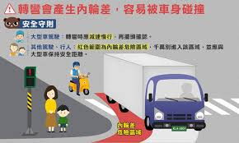

When the pedestrian crossing signal turns green, look left, then right, then left again to make sure no vehicles are running the red light before crossing the street within the crosswalk lines.

當小綠人亮起時，要左看，右看，再左看後，確認沒有闖紅燈車輛，再走行穿線。

There is still the risk of being hit by a vehicle even when crossing the street with a green pedestrian crossing signal. If you encounter turning traffic as you walk across, hold up your hand to catch the driver’s attention and thank the driver for stopping.

綠燈走行穿線穿越路口仍有被車輛碰撞的風險，穿越路口時如有轉彎車，揮手讓司機容易看見，並向司機說謝謝。

If possible, wear light-colored clothing and hats as well as reflective accessories so that drivers can spot you easily.

盡量穿明亮衣帽、反光配件，讓車輛駕駛人容易看見。

Never suddenly dart out into the street.

避免突然衝入車道。

**Keywords**

blind spots 視線死角 run red lights 闖紅燈 pedestrians 行人

foster 培養 sight 視線 crosswalk lines 走行穿線

risk 風險 dart out 突然衝入

資料來源: 交通部